


UROVO

CT58S
Specifications

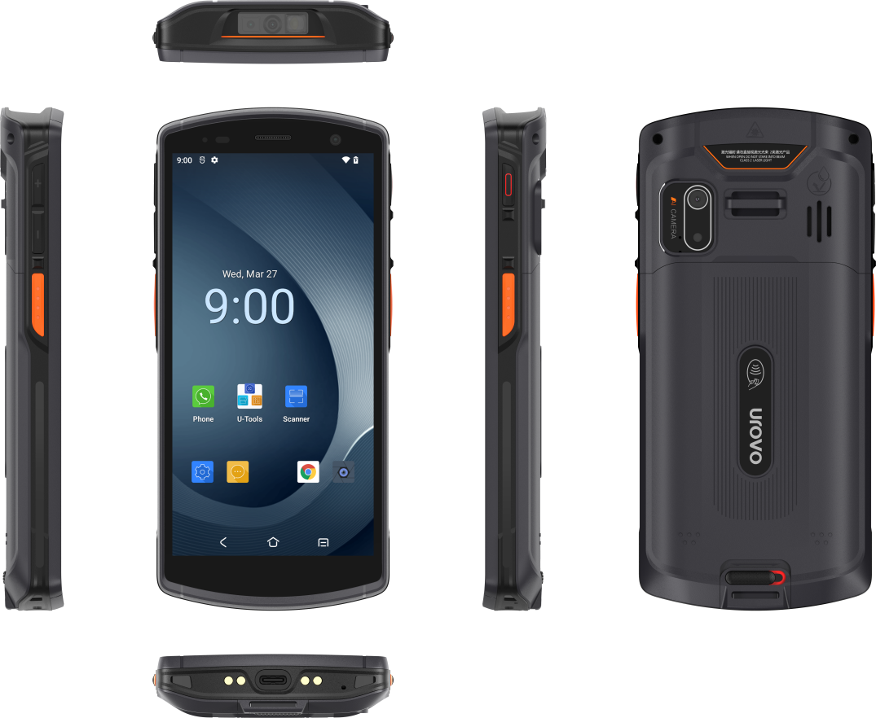

UROVO Technology Co., Ltd.

Specifications
Performance | Model | UROVO CT58S
Performance | O.S. | Android 12.0
Performance | Processor | Octa-core 2.0GHz
Performance | Memory | RAM: 4GB , ROM: 64GB
Performance | Extended memory | Micro SD card, Up to 256 GB SDXC
Basic specifications | Dimensions | 156.9*72.3*16.9mm
Basic specifications | Weight | 9.38 oz./266 g with standard battery
Basic specifications | Display | 5.5 inch display, 720*1440
Basic specifications | Touch Screen | Ultra sensitive capacitive touch panel, support multi-touch, works with gloves and wet fingers
Basic specifications | Main battery | Capacity：3.85V 5000mAh
Basic specifications | Charging time | Less than 4 hours
Basic specifications | Buttons | PWR button, Vol+/- button, Scan button*2
Basic specifications | Camera | Front 5MP, Fixed Focus  Rear 13MP with flash, Auto Focus
Basic specifications | Sensors | Light + Accelerator+ Proximity
Basic specifications | Scanning | Professional scan engine  Support international standard 1D/2D barcode；  Support barcode displayed on screen and colored barcode；
Basic specifications | Slots | One slot, Nano-SIM x 1(Either Micro SD x 1 up to 256GB),  eSIM x 1(optional)
Basic specifications | Audio | Single-Microphone with noise cancellation, 1.5W Speaker for  loud noise , earpiece supports echo cancellation
Basic specifications | Interfaces | USB Type-C、pogo pin
Network Connections | Positioning | GPS、A-GPS、BEIDOU、GLONASS、Galileo
Network Connections | WWAN | 4G/3G/2G
Network Connections | Bluetooth | BT5.0 + BR/EDR + BLE
Network Connections | Wi-Fi | 2.4G/5G，IEEE 802.11a/b/g/n/ac/d/e/h/i/k/r/v/w  Roaming：802.11r /OKC/ PMKID caching
Environment | Operating Temp. | -20°C to 60°C
Environment | Storage Temp. | -40°C to 70°C
Environment | Humidity | 5%RH～95%RH (No condensation)
Environment | Drop Specification | Multiple 1.5 m drops to concrete at room temperature
Environment | Tumbling | 400 1.0m tumbles
Environment | Sealing | IP67
Environment | ESD | +/-15kv Air; +/-8kv contact

Data Capture Specifications
  - Camera
Front Camera
Pixels | 5MP
Rear Camera
Functions | Flash light(700mA), Auto-focus, 1080p video recording
Pixels | 13MP, Auto-focus, 1080p video recording
  - Scan Engine
 | 2D Imager Engine Specifications
Scan Angle Tilt | 360°
Scan Angle Pitch | ±60°
Scan Angle Skew | ±60°
Barcodes Support | Linear: Codabar, Code 11, Code 128, Code 2 of 5, Code 39, Code 93  and 93i, EAN/JAN-13, EAN/JAN 8, IATA Code 2 of 5, Interleaved 2 of 5, Matrix 2 of 5, MSI, GS1 Databar, UPC-A, UPC E, UPC-A/EAN-13  with Extended Coupon Code, Coupon GS1 Code 32(PARAF), EAN-UCC Emulation, GS1 Data Bar  2D Stacked: Codablock A, Codablock F, PDF417, MicroPDF417  2D Matrix: Aztec Code, Data Matrix, MaxiCode, QR Code, Chinese Sensible (Han Xin), Grid Matrix, Dot Code  Postal: Australian Post, British Post, Canadian Post, China Post,  Japanese Post, Korea Post, Netherlands Post, Planet Code, Postnet
3) RFID(HF/NFC)
RFID | HF
Protocol | ISO15693、ISO14443 A/B 、Mifare、Felica
Frequency | 13.56MHz
Mode | Card Emulation、Peer-to-Peer、Reader via Host and UICC
Reading Range | Read distance 0-6cm (ISO15693), 0-4cm(ISO14443A/B)

Network Connections
1) Positioning
Positioning | Specification
Mode | GPS、A-GPS、BEIDOU、GLONASS、Galileo
Frequency | GPS（ L1 1.575GHz C/A code）， BEIDOU（ B1 1.561GHz）， GLONASS(L1 1.602GHz)，Galileo（E1 1.589 GHz / E2 1.561 GHz）
Cold start time | Less than 40s
Max channel | 31 channel
sensitivity | -130dB(SNR value 40 dBHz)
Precision | 5-10 Meters（open space）
2) Wireless LAN
WLAN | Specification
Protocol | IEEE 802.11a/b/g/n/ac/d/e/h/i/k/r/v/w （2.4G/5G dual band Wi-Fi）
Working Channels | CH1~CH13，CH34-CH140，CH149~CH165, depends on country (region)
Security and Encryption | 802.1x,TKIP, AES, PEAPv1, EAP-TLS, EAP-TTLS, PEAP-MSCHAPv2, PEAP-TLS,  PEAP-GTC, PWD,SIM, AKA, WEP, WPA/WPA2-PSK
Fast roaming | PMIKD caching;Support 802.11r fast roaming(Over the-Air),  roaming threshold can be set
3) Wireless WAN
WWAN | Specification
Default frequency band | TD-LTE(B34/B38/B39/B40/B41)  FDD-LTE(B1/B2/B3/B4/B5/B7/B8/B20/B28A/B28B)  WCDMA(B1/B2/B4/B5/B8)  TD-SCDMA(B34/B39)  CDMA&EVDO:BC0  GSM/EDGE/GPRS(850/900/1800/1900）
4) Wireless PAN
BT | Specification
Mode | BT5.0 + BR/EDR + BLE
Range | More than 10 Meters

Accessories
 | Type
Standard Accessory | Adapter*1, Type-C cable*1, Battery*1, Instructions & Security Information & Warranty Card*1
Optional Accessory | Single Slot Charging Cradle, Screen Protector, Hand Strap, Hand Rope, Rugged Boot

